Nicholas Shari

CSE422

Homework #4

Due: 11/29/2022

Chapter 4:#1, 2, 4, 6, 11, 14, 16, 19

Chapter 5:#3, 5, 12, 14 15, 19, 21

P1. Consider the network below. a. Show the forwarding table in router A, such that all traffic destined to host H3 is forwarded through interface 3.

Destination Address Link Interface

H3 3

b. Can you write down a forwarding table in router A, such that all traffic from H1 destined to host H3 is forwarded through interface 3, while all traffic from H2 destined to host H3 is forwarded through interface 4? (Hint: This is a trick question.)

No. Forwarding is based on the destination address.

P2. Suppose two packets arrive to two different input ports of a router at exactly the same time. Also suppose there are no other packets anywhere in the router.

a. Suppose the two packets are to be forwarded to two different output ports. Is it possible to forward the two packets through the switch fabric at the same time when the fabric uses a shared bus?

* No. Only one packet can be sent at a time through a shared bus.

b. Suppose the two packets are to be forwarded to two different output ports. Is it possible to forward the two packets through the switch fabric at the same time when the fabric uses switching via memory?

* No. Only one read/write to memory can occur at a time.

c. Suppose the two packets are to be forwarded to the same output port. Is it possible to forward the two packets through the switch fabric at the same time when the fabric uses a crossbar?

* No. The packets would need to go through the same shared bus to arrive at the same port. Only one packet can go at a time.

P4. Consider the switch shown below. Suppose that all datagrams have the same fixed length, that the switch operates in a slotted, synchronous manner, and that in one time slot a datagram can be transferred from an input port to an output port. The switch fabric is a crossbar so that at most one datagram can be transferred to a given output port in a time slot, but different output ports can receive datagrams from different input ports in a single time slot.

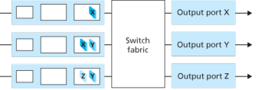

What is the minimal number of time slots needed to transfer the packets shown from input ports to their output ports, assuming any input queue scheduling order you want (i.e., it need not have HOL blocking)?

3

Time Slot 1: x in top input queue, y in middle

Time Slot 2: x in middle input, y in bottom input queue

Time Slot 3: z in bottom input

What is the largest number of slots needed, assuming the worst-case scheduling order you can devise, assuming that a non-empty input queue is never idle?

3.

Non-empty and never idle.

X at the top, Y or X in the middle, any leftover at the bottom.

P6. Consider a datagram network using 8-bit host addresses. Suppose a

router uses longest prefix matching and has the following forwarding table:

| Prefix Match | Link Interface | Destination Address Range | Number of Addresses |
| --- | --- | --- | --- |
| 00 | 0 | 0000000 - 00111111 | 2^6 = 64 |
| 010 | 1 | 0100000 - 01011111 | 2^5 =32 |
| 011 | 2 | 0110000 - 01111111 | 2^6 +2^5 = 96 |
| 10 | 2 | 10000000 - 10111111 | 96 |
| 11 | 3 | 11000000 - 11111111 | 2^6 = 64 |

P11. Consider a subnet with prefix 128.119.40.128/26.

Give an example of one IP address (of form xxx.xxx.xxx.xxx) that can be assigned to this network. 128.119.40.130

Suppose an ISP owns the block of addresses of the form 128.119.40.64/26. Suppose it wants to create four subnets from this block, with each block having the same number of IP addresses.

What are the prefixes (of form a.b.c.d/x) for the four subnets?

Network bits 26. Host bits 6 for 32bit IP address

8bits . 8 bits . 8 bits. 01000000 (64)

4 subnets requires reserving extra bits for subnets. 28bits total for host

8bits . 8 bits. 8 bits. 0100 0000 (64)

. 0101 0000 (80)

.0110 0000 (96)

.0111 0000 (112)

128.119.40.64/28

128.119.40.80/28

128.119.40.96/28

128.119.40.112/28

P14. Consider sending a 2400-byte datagram into a link that has an MTU of 700 bytes. Suppose the original datagram is stamped with the identification number 422.

How many fragments are generated?

20bytes of IP header.

Fragment = MTU - IP = 700 - 20 = 680bytes.

Fragments = [datagram - ip] / fragment size = [2400-20]/680 = 3.6

Therefore, 4 fragments are required.

What are the values in the various fields in the IP datagram(s) generated related to fragmentation?

1st Fragment: 700bytes (including header)

2nd Fragment:700bytes (including header)

3rd Fragment:700bytes (including header)

4th Fragment: 360bytes(including header) 2400 - (680*3) + 20(header)

680/8 = 85. Offsets of 85

Offsets of each fragments 1st - 0, 2nd -85, 3rd - 170, 4th - 255

The first 3 fragments will have a flag of 1 and the 4th fragment has a flag = 0 since it is the last fragment.

P16. Consider the network setup in Figure 4.25 .

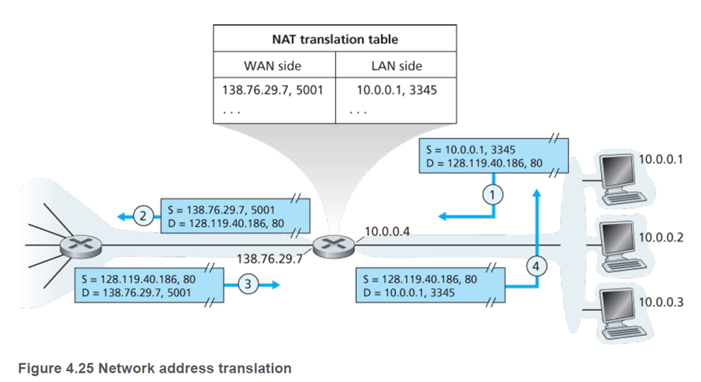

Suppose that the ISP instead assigns the router the address 24.34.112.235 and that the network address of the home network is 192.168.1/24.

a. Assign addresses to all interfaces in the home network.

Home network address interface: 192.168.1.1, 192.168.1.2, 192.168.1.3

Router interface: 192.168.1.4

b. Suppose each host has two ongoing TCP connections, all to port 80 at host 128.119.40.86. Provide the six corresponding entries in the NAT translation table.

On the WAN Side, the router chooses an arbitrary port number for the host. On the LAN Side the host has chosen an arbitrary port number to identify itself to the router. The router replaces the host port with the new port before sending it out. The router also replaces the local IP with its own IP.

NAT Translation Table

WAN Side LAN Side

| 24.34.112.235 | 5000 | 192.168.1.1 | 3345 |
| --- | --- | --- | --- |
| 24.34.112.235 | 5001 | 192.168.1.1 | 3346 |
| 24.34.112.235 | 5002 | 192.168.1.2 | 3445 |
| 24.34.112.235 | 5003 | 192.168.1.2 | 3446 |
| 24.34.112.235 | 5004 | 192.168.1.3 | 3545 |
| 24.34.112.235 | 5005 | 192.168.1.3 | 3546 |

P19. Consider the SDN OpenFlow network shown in Figure 4.30 .

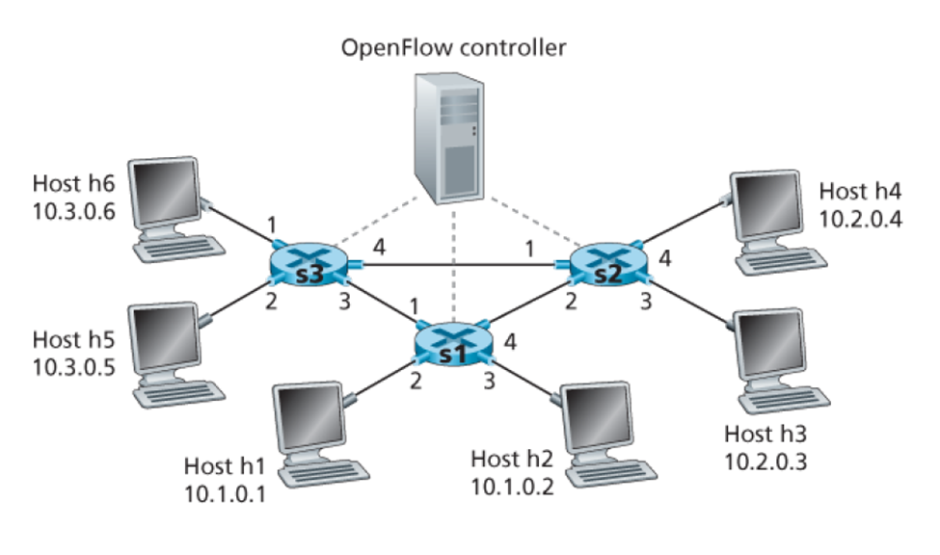



Suppose that the desired forwarding behavior for datagrams arriving at s2 is as follows:

* any datagrams arriving on input port 1 from hosts h5 or h6 that are destined to hosts h1 or h2 should be forwarded over output port 2;
* any datagrams arriving on input port 2 from hosts h1 or h2 that are destined to hosts h5 or h6 should be forwarded over output port 1;
* any arriving datagrams on input ports 1 or 2 and destined to hosts h3 or h4 should be delivered to the host specified;
* hosts h3 and h4 should be able to send datagrams to each other

Specify the flow table entries in s2 that implement this forwarding behavior.

S2 Flow Table

| Match | Action |
| --- | --- |
| Ingress Port = 1; IP Src = 10.3.*.*; IP Dst = 10.1.*.* | Forward (2) |
| Ingress Port = 2; IP Src = 10.1.*.*; IP Dst = 10.3.*.* | Forward (1) |
| Ingress Port = 1; IP Dst = 10.2.0.3  Ingress Port = 2; IP Dst = 10.2.0.3  Ingress Port = 1; IP Dst = 10.2.0.4  Ingress Port = 2; IP Dst = 10.2.0.4 | Forward (3)  Forward (3)  Forward (4)  Forward (4) |
| Ingress Port = 4  Ingress Port = 3 | Forward (3)  Forward (4) |

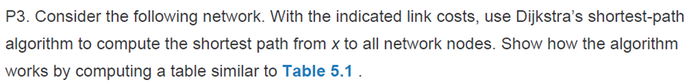

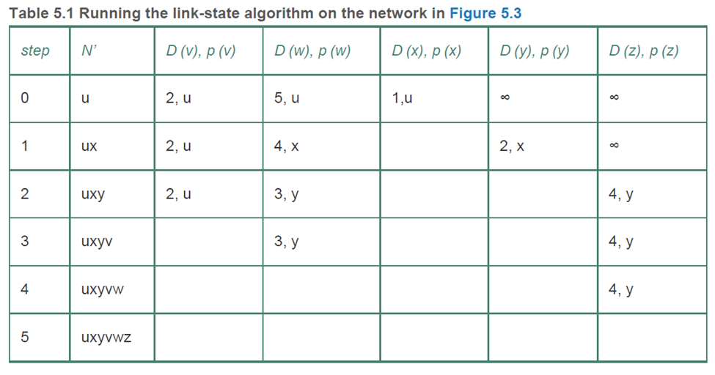

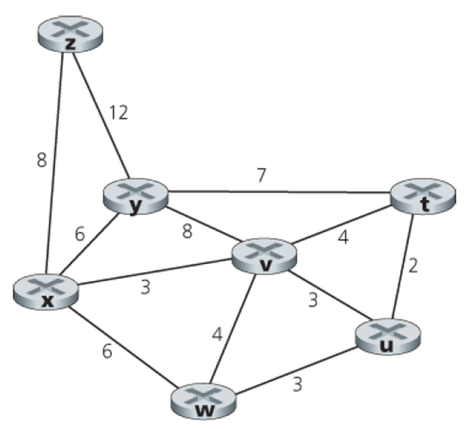

| Step | N’ | D(t),p(t) | D(u),p(u) | D(v),p(v) | D(w),p(w) | D(y),p(y) | D(z),p(z) |
| --- | --- | --- | --- | --- | --- | --- | --- |
| 0 | x | inf | inf | 3,x | 6,x | 6,x | 8,x |
| 1 | xv | 7,v | 6,u | 3,x | 6,x | 6,x | 8,x |
| 2 | xvu | 7,v | 6,u | 3,x | 6,x | 6,x | 8,x |
| 3 | xvuw | 7,v | 6,u | 3,x | 6,x | 6,x | 8,x |
| 4 | xvuwy | 7,v | 6,u | 3,x | 6,x | 6,x | 8,x |
| 5 | xvuwyt | 7,v | 6,u | 3,x | 6,x | 6,x | 8,x |
| 6 | xvuwytz | 7,v | 6,u | 3,x | 6,x | 6,x | 8,x |

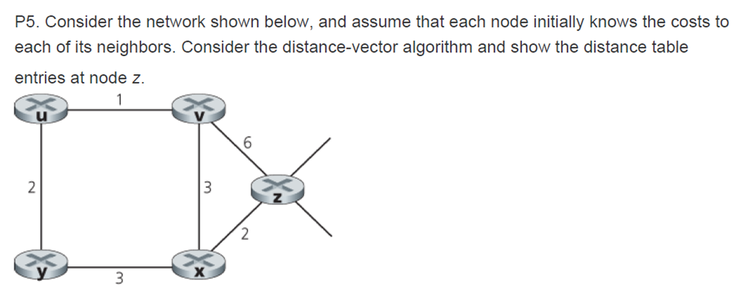

Cost to

|  |  | u | v | x | y | z |
| --- | --- | --- | --- | --- | --- | --- |
|  | v | ∞ | ∞ | ∞ | ∞ | ∞ |
| From | x | ∞ | ∞ | ∞ | ∞ | ∞ |
|  | z | ∞ | 6 | 2 | ∞ | 0 |

Cost to

|  |  | u | v | x | y | z |
| --- | --- | --- | --- | --- | --- | --- |
|  | v | 1 | 0 | 3 | ∞ | 6 |
| From | x | ∞ | 3 | 0 | 3 | 2 |
|  | z | 7 | 5 | 2 | 5 | 0 |

Cost to

|  |  | u | v | x | y | z |
| --- | --- | --- | --- | --- | --- | --- |
|  | v | 1 | 0 | 3 | 3 | 5 |
| From | x | 4 | 3 | 0 | 3 | 2 |
|  | z | 6 | 5 | 2 | 5 | 0 |

Cost to

|  |  | u | v | x | y | z |
| --- | --- | --- | --- | --- | --- | --- |
|  | v | 1 | 0 | 3 | 3 | 5 |
| From | x | 4 | 3 | 0 | 3 | 2 |
|  | z | 6 | 5 | 2 | 5 | 0 |

P12. Describe how loops in paths can be detected in BGP.

BGP advertisements have the complete paths which show the AS’s that the path will go through. If an AS appears more than once, a router will identify that as a loop.

P14. Consider the network shown below. Suppose AS3 and AS2 are running OSPF for their intra-AS routing protocol. Suppose AS1 and AS4 are running RIP for their intra-AS routing protocol. Suppose eBGP and iBGP are used for the inter-AS routing protocol. Initially suppose there is no physical link between AS2 and AS4.

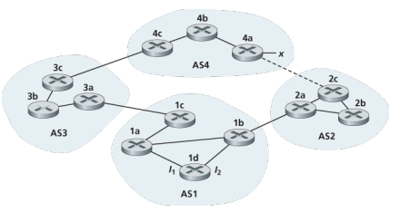

a. Router 3c learns about prefix x from which routing protocol: OSPF, RIP, eBGP, or iBGP?

* eBGP

b. Router 3a learns about x from which routing protocol?

* iBGP

c. Router 1c learns about x from which routing protocol?

* eBGP

d. Router 1d learns about x from which routing protocol?

* iBGP

P15. Referring to the previous problem, once router 1d learns about x it will put an entry (x, I) in its forwarding table.

a. Will I be equal to I1 or I2 for this entry? Explain why in one sentence.

* I1 because the least cost path from 1d to the gateway router 1c is through this path.

b. Now suppose that there is a physical link between AS2 and AS4, shown by the dotted line. Suppose router 1d learns that x is accessible via AS2 as well as via AS3. Will I be set to I1 or I2 ? Explain why in one sentence.

* I2 because it has the closest Next-Hop router even though both paths has the same AS-path length.

c. Now suppose there is another AS, called AS5, which lies on the path between AS2 and AS4 (not shown in diagram). Suppose router 1d learns that x is accessible via AS2 AS5 AS4 as well as via AS3 AS4. Will I be set to I1 or I2 ? Explain why in one sentence.

* I1 because AS3 AS4 is the shortest AS-path.

P19. In Figure 5.13 ,

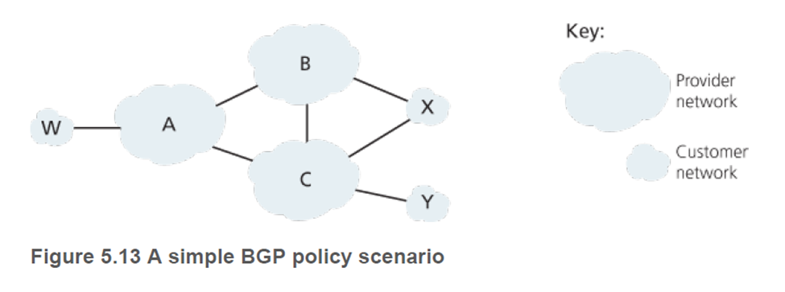

suppose that there is another stub network V that is a customer of ISP A. Suppose that B and C have a peering relationship, and A is a customer of both B and C. Suppose that A would like to have the traffic destined to W to come from B only, and the traffic destined to V from either B or C.

How should A advertise its routes to B and C?

* A advertises to B the AS paths: A-W and A-V
* A advertises to C only the AS path: A-V

What AS routes does C receive?

B-A-W, B-A-V, A-V (since A only wants W to be routable to B).

P21. Consider the two ways in which communication occurs between a managing entity and a managed device: request-response mode and trapping. What are the pros and cons of these two approaches, in terms of (1) overhead, (2) notification time when exceptional events occur, and (3) robustness with respect to lost messages between the managing entity and the device?

Overhead:

Request-response mode: Has more overhead as it generates a poll and response message.

Trapping: Has less overhead as there is only a single message to the sender.

Notification Time:

Request-response mode: Manager has to wait on average half the polling cycle to receive a notice.

Trapping; Manager is immediately notified.

Robustness:

Request-response mode: If a message is lost, the receiver will never get a reply message. Then the manager repolls for the lost message. This guarantees receipt.

Trapping: The sender only gets a single trap message. If it is lost, nothing tells it to resend.